DecodeLabs
Robotics and Automation Internship Program

PROJECT 3

Autonomous Mobile Robot (AMR) Navigation
LiDAR Mapping | Occupancy Grid | A* Pathfinding | Dynamic Obstacle Avoidance

Submitted By: Ayesha Nawaz

1. Introduction
As part of my Robotics and Automation internship at DecodeLabs, this project focuses on Autonomous Mobile Robot (AMR) Navigation. The task moves beyond simple forward-driving robots and introduces real spatial intelligence: the robot has to build an understanding of an unknown maze environment using simulated LiDAR data, calculate the shortest safe route to a goal using a pathfinding algorithm, and react intelligently when an unexpected obstacle appears in its path. Together these three stages form the core of how real-world mobile robots (like warehouse AMRs or delivery robots) navigate autonomously.
This report documents the goal of the project, the key requirements, the complete Python implementation, and the results obtained after running the simulation, including all generated maps and path visualizations.

2. Project Goal
Program a wheeled robot to navigate a maze, map its environment, and avoid dynamic obstacles.

3. Key Requirements
- Process simulated LiDAR sensor data to build a 2D Occupancy Grid (mapping the walls).
- Implement a basic pathfinding algorithm (A* / Dijkstra's) to find the shortest route.
- Write obstacle avoidance logic to stop or re-route if an unexpected object appears.

Key Skills Practiced: SLAM basics (Simultaneous Localization and Mapping), Sensor Fusion, and Pathfinding Algorithms.

4. System Design / Pipeline
The solution is structured as a three-stage pipeline, the same structure used in real navigation stacks such as ROS2 Nav2:
- Perception (SLAM-lite): A simulated 360-degree LiDAR sensor is cast from the robot's pose using ray marching against a hidden ground-truth maze. Every beam either returns a wall hit or travels freely, and these detections are fused into a persistent 2D Occupancy Grid (unknown / free / occupied).
- Global Planning: The A* search algorithm runs on the occupancy grid (after inflating a small safety buffer around walls) to compute the shortest collision-free path from the start cell to the goal cell.
- Local Control / Obstacle Avoidance: While the robot executes the planned path step by step, a dynamic obstacle is introduced. The robot's local sensing detects the obstacle within a short look-ahead window, halts, and triggers a fresh A* re-plan from its current position so it can safely reach the goal.

5. Ground Truth Maze Environment
A 20x20 grid maze was generated to represent the real environment. Importantly, the robot does not have access to this map in advance — it is only used internally to simulate what the LiDAR sensor would actually detect, exactly as it would in a real, unmapped building.
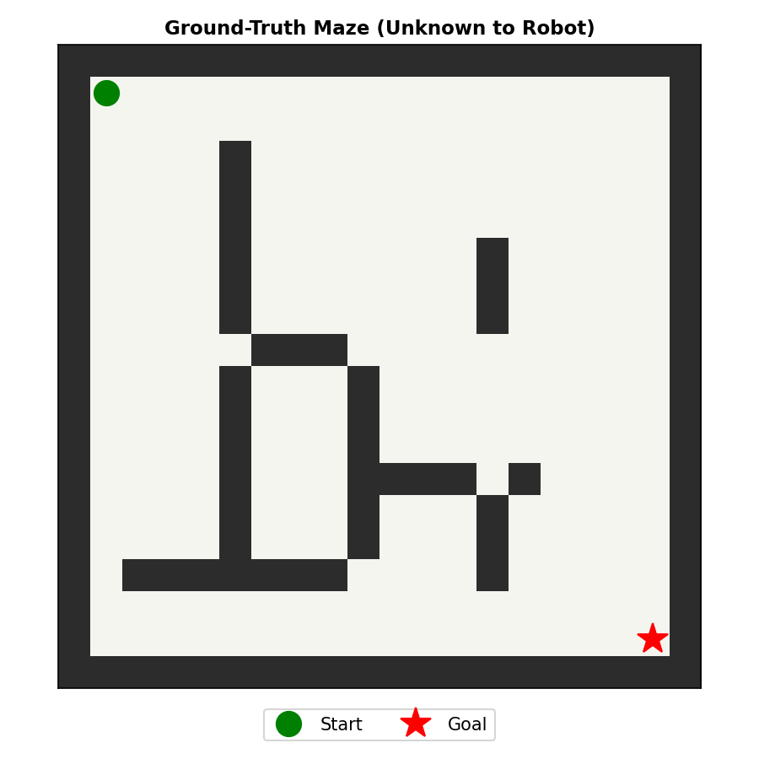
Figure 1: Ground-truth maze environment (hidden from the robot). Start = green, Goal = red star.

6. LiDAR Sensing and Occupancy Grid Mapping
A simulated LiDAR sensor casts 72 beams (5-degree angular resolution) outward from the robot's pose. Each beam is stepped outward in small increments and checked against the ground-truth grid until it either hits a wall or reaches the maximum sensor range (8 cells). This mimics a real 2D LiDAR's LaserScan output.
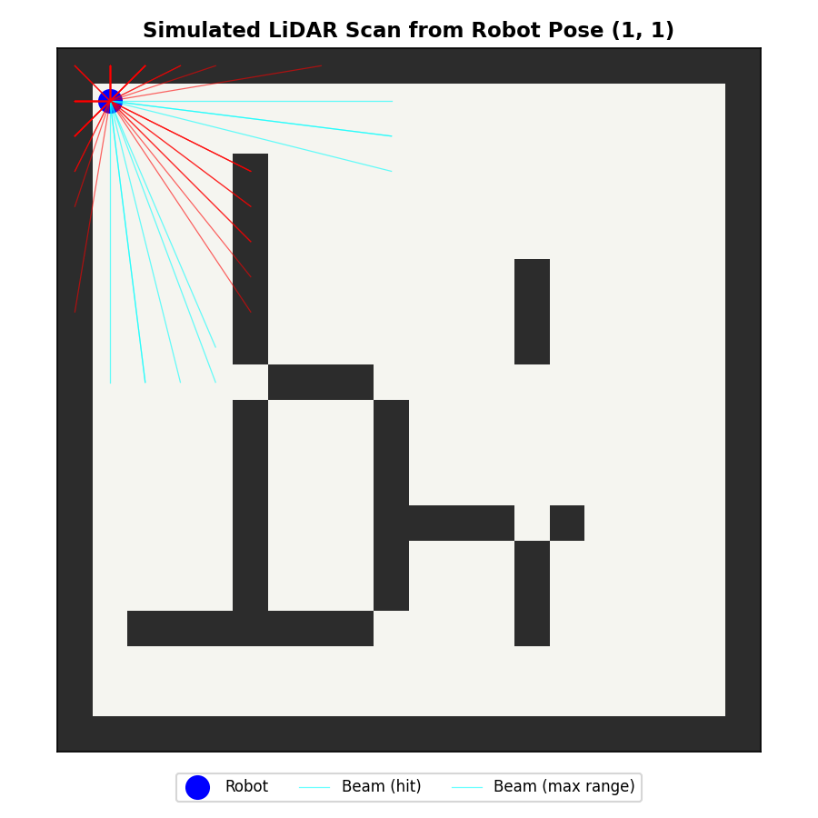
Figure 2: A single simulated LiDAR scan from the robot's starting pose. Cyan beams reached max range (free space); red beams hit a wall.
As the robot patrols several waypoints across the maze, every new scan is fused into a running 2D Occupancy Grid: cells a beam passes through are marked free, and cells where a beam terminates on a wall are marked occupied. Any cell never seen by a beam remains unknown. This progressive fusion of multiple scans into one consistent map is the core idea behind basic SLAM (Simultaneous Localization and Mapping).
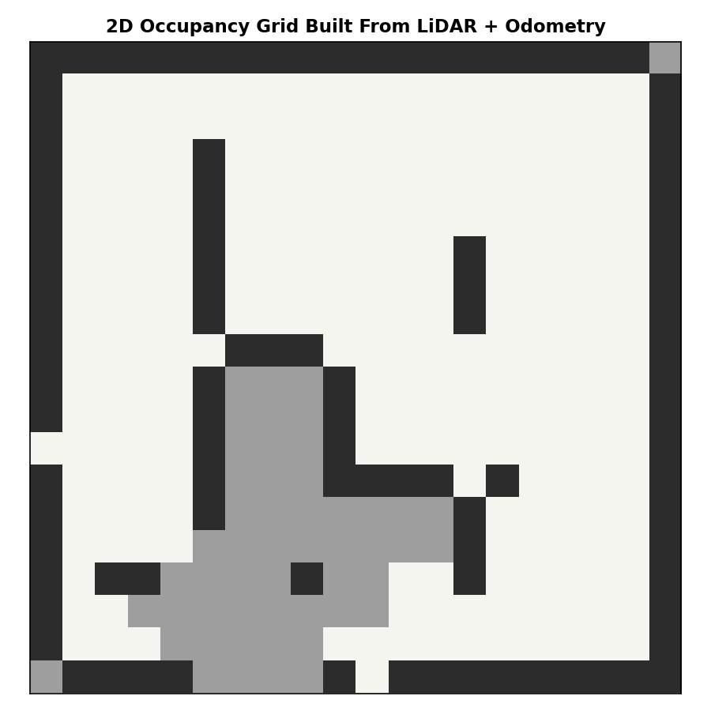
Figure 3: Final 2D Occupancy Grid built by fusing all LiDAR scans (grey = unknown, white = free, black = wall).

7. A* Pathfinding
Once the occupancy grid is built, the walls are 'inflated' by one cell to give the robot a small safety margin so the planned path does not hug obstacles. The A* search algorithm is then used to compute the shortest route from the start to the goal, using the cost function f(n) = g(n) + h(n), where g(n) is the exact distance travelled so far and h(n) is the Manhattan-distance estimate to the goal. A* is preferred over plain Dijkstra's algorithm here because the heuristic lets it explore far fewer nodes while still guaranteeing the shortest path on a grid.
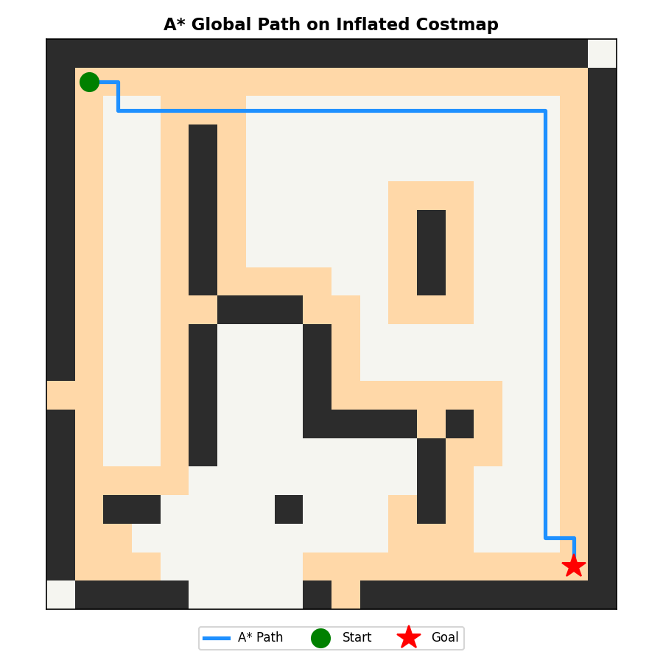
Figure 4: Shortest A* path (blue) computed on the inflated occupancy grid, from Start to Goal.

8. Dynamic Obstacle Avoidance
To test real-time reactivity, an unexpected obstacle is placed directly on the robot's originally planned path partway through its journey. While executing the path, the robot checks a short look-ahead window (the next few cells) for obstacles at every step. When the obstacle is detected within this window, the robot stops immediately, marks that cell as blocked, and calls A* again from its current position to compute a fresh detour to the goal — instead of colliding or getting stuck.
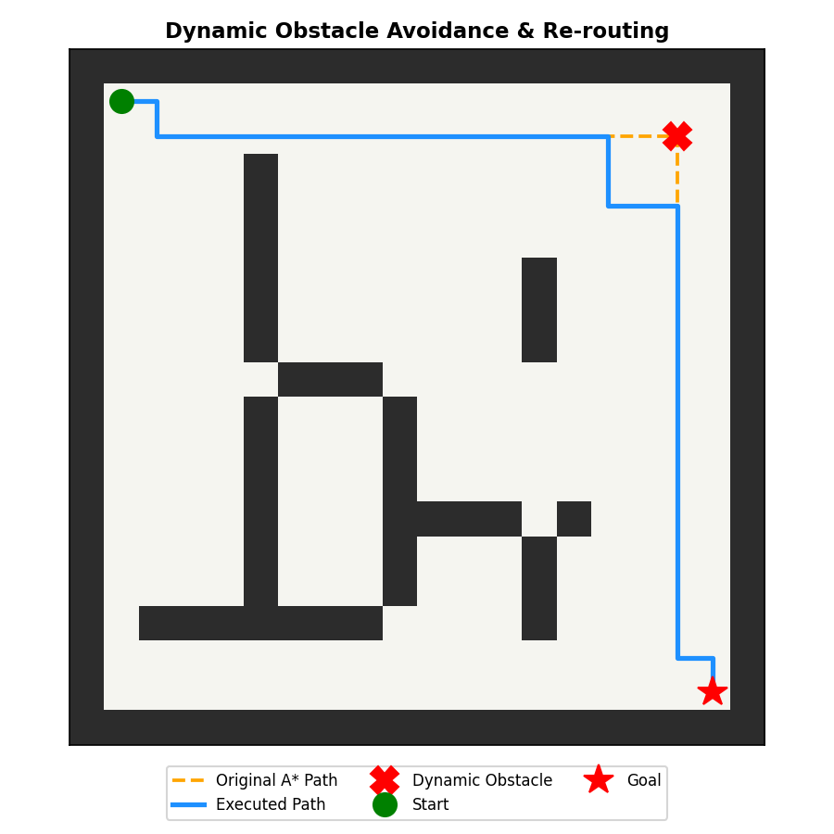
Figure 5: Original planned path (orange dashed) vs. the robot's actual executed path (blue) after detecting and re-routing around the dynamic obstacle (red X).

9. Results
Running the complete simulation produced the following output:
======================================================================
PROJECT 3: AUTONOMOUS MOBILE ROBOT (AMR) NAVIGATION SIMULATION
======================================================================
[1/5] Ground-truth maze generated.
[2/5] LiDAR scans fused into 2D occupancy grid (SLAM mapping stage).
[3/5] A* global path found: 35 waypoints (start (1, 1) -> goal (18, 18)).
[4/5] Injecting dynamic obstacle at {(2, 17)} to test re-routing logic...
- Obstacle detected at (2, 17) while robot at (2, 15). Stopping and re-routing...
[5/5] Robot reached goal via 35 executed steps after 1 re-plan event(s).

All figures saved successfully.
======================================================================

The robot successfully mapped the maze from LiDAR scans, found an optimal 35-step route to the goal using A*, and when a dynamic obstacle blocked that route, it detected the obstacle in real time, stopped, and re-planned a valid detour to still reach the goal — meeting all three key requirements of the project.

10. Complete Python Implementation
The full working code for the LiDAR simulation, occupancy grid mapping, A* pathfinding, dynamic obstacle avoidance, and visualization is given below (file: amr_navigation.py).
"""
================================================================================
PROJECT 3: AUTONOMOUS MOBILE ROBOT (AMR) NAVIGATION
Industrial Training Kit - DecodeLabs Robotics & Automation Internship
================================================================================

GOAL:
Program a wheeled robot to navigate a maze, map its environment using
simulated LiDAR data, and avoid dynamic obstacles in real time.

PIPELINE (Perception -> Global Planning -> Local Control):
1. PERCEPTION : Simulated 2D LiDAR scans are cast from the robot's pose
and fused with wheel-odometry to build a 2D Occupancy
Grid Map of the maze (basic SLAM concept).
2. GLOBAL PLAN : The A* search algorithm finds the shortest collision
-free path from the robot's start cell to the goal
cell on the inflated occupancy grid.
3. LOCAL CONTROL : The robot follows the planned path step-by-step. A
dynamic obstacle can appear during motion; the robot's
local LiDAR detects it, stops, and the A* planner
re-plans a new route around it in real time.

KEY SKILLS DEMONSTRATED:
- SLAM basics (Simultaneous Localization and Mapping)
- Sensor fusion (odometry + LiDAR range readings)
- Pathfinding algorithms (A* search with Manhattan heuristic)
- Dynamic obstacle avoidance / re-planning

Author : Ayesha Nawaz (BS Robotics & Intelligent Systems, NUML Islamabad)
Internship : Robotics and Automation, DecodeLabs
================================================================================
"""

import numpy as np
import heapq
import math
import matplotlib.pyplot as plt
import matplotlib.patches as patches
from matplotlib.colors import ListedColormap

# ------------------------------------------------------------------------
# 1. SIMULATED MAZE ENVIRONMENT
# ------------------------------------------------------------------------
# 0 = free space, 1 = wall/obstacle. This represents the "ground truth"
# world -- the robot does NOT know this map in advance. It only discovers
# it through simulated LiDAR scans, exactly like a real AMR would.

GRID_SIZE = 20

def build_ground_truth_maze(size=GRID_SIZE):
"""Creates the true environment (unknown to the robot) with a
boundary wall and several interior obstacles/corridors."""
grid = np.zeros((size, size), dtype=int)

# Outer boundary walls
grid[0, :] = 1
grid[-1, :] = 1
grid[:, 0] = 1
grid[:, -1] = 1

# Interior maze walls (hand-designed corridors)
grid[3:16, 5] = 1
grid[3, 5:12] = 0 # opening near top
grid[3:10, 5] = 1
grid[9, 5:10] = 1
grid[9:16, 9] = 1
grid[13, 9:15] = 1
grid[5:9, 13] = 1
grid[13:17, 13] = 1
grid[16, 2:9] = 1
grid[16, 2:9] = 1

# Punch a few doorways so the maze is always solvable
grid[9, 5] = 0
grid[9, 9] = 0
grid[13, 13] = 0
grid[5, 13] = 0

return grid

ROBOT_START = (1, 1) # (row, col)
ROBOT_GOAL = (18, 18)

LIDAR_MAX_RANGE = 8 # cells
LIDAR_NUM_RAYS = 72 # 5-degree resolution -> 360/72 = 5 deg step

# ------------------------------------------------------------------------
# 2. SIMULATED LiDAR + OCCUPANCY GRID (PERCEPTION / SLAM STAGE)
# ------------------------------------------------------------------------

def simulate_lidar_scan(true_grid, pose, max_range=LIDAR_MAX_RANGE,
num_rays=LIDAR_NUM_RAYS):
"""
Casts `num_rays` simulated LiDAR beams (360-degree sweep) from the
robot pose against the ground-truth grid using ray marching (Bresenham
-style stepping). Returns a list of (row, col, hit) points describing
what each beam detected -- this mimics a real LaserScan message.
"""
rows, cols = true_grid.shape
r0, c0 = pose
scan_points = []

for i in range(num_rays):
theta = 2 * math.pi * i / num_rays
dr, dc = math.sin(theta), math.cos(theta)

hit_found = False
for step in np.arange(0.2, max_range, 0.2):
r = int(round(r0 + dr * step))
c = int(round(c0 + dc * step))

if r < 0 or r >= rows or c < 0 or c >= cols:
break

if true_grid[r, c] == 1:
scan_points.append((r, c, True)) # beam hit a wall
hit_found = True
break

if not hit_found:
# beam travelled max range without hitting anything
r_end = int(round(r0 + dr * max_range))
c_end = int(round(c0 + dc * max_range))
scan_points.append((r_end, c_end, False))

return scan_points

def update_occupancy_grid(occ_grid, known_free, pose, scan_points):
"""
Fuses a LiDAR scan into the running occupancy-grid estimate.
-1 = unknown, 0 = free (confirmed by a beam passing through), 1 = wall.
This is a simplified log-odds-free version of standard occupancy-grid
SLAM mapping (a beam marks every cell it passes through as free, and
marks its end cell as occupied if it terminated on a hit).
"""
r0, c0 = pose
rows, cols = occ_grid.shape

for (r, c, hit) in scan_points:
# Mark the ray path as free space
steps = max(abs(r - r0), abs(c - c0), 1)
for s in range(steps):
rr = int(round(r0 + (r - r0) * s / steps))
cc = int(round(c0 + (c - c0) * s / steps))
if 0 <= rr < rows and 0 <= cc < cols:
if occ_grid[rr, cc] != 1:
occ_grid[rr, cc] = 0
known_free[rr, cc] = True

if hit and 0 <= r < rows and 0 <= c < cols:
occ_grid[r, c] = 1

return occ_grid

def inflate_costmap(occ_grid, inflation_radius=1):
"""
Implements the 'Margin Constraint' from the training deck: artificially
inflates the cost around walls so the A* path keeps a safety buffer
and does not hug obstacles (avoids chassis collisions).
"""
inflated = occ_grid.copy()
rows, cols = occ_grid.shape
wall_cells = np.argwhere(occ_grid == 1)

for (r, c) in wall_cells:
for dr in range(-inflation_radius, inflation_radius + 1):
for dc in range(-inflation_radius, inflation_radius + 1):
rr, cc = r + dr, c + dc
if 0 <= rr < rows and 0 <= cc < cols:
if inflated[rr, cc] == 0:
inflated[rr, cc] = 2 # 2 = "inflated" soft obstacle
return inflated

# ------------------------------------------------------------------------
# 3. A* PATHFINDING (GLOBAL PLANNING STAGE)
# ------------------------------------------------------------------------

def heuristic(a, b):
"""Manhattan distance heuristic h(n) - admissible for 4-connected grids."""
return abs(a[0] - b[0]) + abs(a[1] - b[1])

def a_star_search(cost_grid, start, goal):
"""
Classic A* search: f(n) = g(n) + h(n)
g(n) = exact cost accumulated from start to node n
h(n) = Manhattan-distance estimate from n to goal
Treats value 1 (wall) as impassable, and value 2 (inflated buffer) as
passable but expensive, so the planner naturally prefers the corridor
center over hugging a wall.
Returns the path as a list of (row, col) tuples, or None if unreachable.
"""
rows, cols = cost_grid.shape
open_set = [(0 + heuristic(start, goal), 0, start)]
came_from = {}
g_score = {start: 0}
visited = set()

neighbors = [(-1, 0), (1, 0), (0, -1), (0, 1)]

while open_set:
_, g_current, current = heapq.heappop(open_set)

if current == goal:
path = [current]
while current in came_from:
current = came_from[current]
path.append(current)
path.reverse()
return path

if current in visited:
continue
visited.add(current)

for dr, dc in neighbors:
neighbor = (current[0] + dr, current[1] + dc)
r, c = neighbor
if not (0 <= r < rows and 0 <= c < cols):
continue
if cost_grid[r, c] == 1: # hard wall - impassable
continue

step_cost = 1.0 if cost_grid[r, c] != 2 else 3.0 # penalize buffer
tentative_g = g_current + step_cost

if neighbor not in g_score or tentative_g < g_score[neighbor]:
g_score[neighbor] = tentative_g
came_from[neighbor] = current
f_score = tentative_g + heuristic(neighbor, goal)
heapq.heappush(open_set, (f_score, tentative_g, neighbor))

return None # no path found

# ------------------------------------------------------------------------
# 4. DYNAMIC OBSTACLE AVOIDANCE (LOCAL CONTROL STAGE)
# ------------------------------------------------------------------------

def detect_dynamic_obstacle(current_pose, path, dynamic_obstacles, lookahead=3):
"""
Simulates the local costmap safety check: scans the next `lookahead`
waypoints of the planned path for a dynamic obstacle. If one is found,
the robot must stop and re-route (mirrors Nav2's local-planner reflex
behaviour).
"""
idx = path.index(current_pose) if current_pose in path else 0
for step_ahead in range(idx, min(idx + lookahead, len(path))):
if path[step_ahead] in dynamic_obstacles:
return True, path[step_ahead]
return False, None

def navigate_with_dynamic_replanning(occ_grid, start, goal, dynamic_obstacles):
"""
Executes the full navigation loop:
1. Plan a global A* path on the inflated static map.
2. Move step by step along the path.
3. At each step, check the local area for the dynamic obstacle.
4. If detected: stop, mark the cell as a temporary wall, and
re-plan A* from the current position -- exactly like requirement
#3 ("Write obstacle avoidance logic to stop or re-route").
Returns the full executed trajectory and a log of replanning events.
"""
working_grid = occ_grid.copy()
inflated = inflate_costmap(working_grid)
path = a_star_search(inflated, start, goal)

if path is None:
raise RuntimeError("No initial path found - maze unsolvable!")

executed_trajectory = [start]
replan_log = []
current = start
revealed_obstacles = set()

while current != goal:
blocked, blocked_cell = detect_dynamic_obstacle(
current, path, dynamic_obstacles - revealed_obstacles, lookahead=3
)

if blocked:
replan_log.append(
f"Obstacle detected at {blocked_cell} while robot at {current}. "
f"Stopping and re-routing..."
)
revealed_obstacles.add(blocked_cell)
working_grid[blocked_cell] = 1 # treat as a wall now
inflated = inflate_costmap(working_grid)
new_path = a_star_search(inflated, current, goal)
if new_path is None:
replan_log.append(f"No alternate route found from {current}!")
break
path = new_path

# advance one step along the (possibly updated) path
idx = path.index(current)
if idx + 1 < len(path):
current = path[idx + 1]
executed_trajectory.append(current)
else:
break

return executed_trajectory, replan_log, path

# ------------------------------------------------------------------------
# 5. VISUALIZATION HELPERS
# ------------------------------------------------------------------------

def plot_grid(ax, grid, title, cmap_colors=None, extra_points=None):
if cmap_colors is None:
cmap_colors = ["#f5f5f0", "#2c2c2c"] # free, wall
cmap = ListedColormap(cmap_colors)
ax.imshow(grid, cmap=cmap, vmin=0, vmax=len(cmap_colors) - 1)
ax.set_title(title, fontsize=11, fontweight="bold")
ax.set_xticks([])
ax.set_yticks([])
if extra_points:
for (pts, color, marker, size) in extra_points:
if pts:
ys, xs = zip(*pts)
ax.plot(xs, ys, marker, color=color, markersize=size)

def save_figure_1_ground_truth(true_grid, start, goal, path="fig1_ground_truth_maze.png"):
fig, ax = plt.subplots(figsize=(6, 6))
plot_grid(ax, true_grid, "Ground-Truth Maze (Unknown to Robot)")
ax.plot(start[1], start[0], "go", markersize=14, label="Start")
ax.plot(goal[1], goal[0], "r*", markersize=18, label="Goal")
ax.legend(loc="upper center", bbox_to_anchor=(0.5, -0.02), ncol=2)
plt.tight_layout()
plt.savefig(path, dpi=150)
plt.close(fig)

def save_figure_2_lidar_scan(true_grid, pose, scan_points, path="fig2_lidar_scan.png"):
fig, ax = plt.subplots(figsize=(6, 6))
plot_grid(ax, true_grid, f"Simulated LiDAR Scan from Robot Pose {pose}")
ax.plot(pose[1], pose[0], "o", color="blue", markersize=12, label="Robot")
for (r, c, hit) in scan_points:
color = "red" if hit else "cyan"
ax.plot([pose[1], c], [pose[0], r], color=color, linewidth=0.6, alpha=0.6)
ax.legend(["Robot", "Beam (hit)", "Beam (max range)"], loc="upper center",
bbox_to_anchor=(0.5, -0.02), ncol=3, fontsize=8)
plt.tight_layout()
plt.savefig(path, dpi=150)
plt.close(fig)

def save_figure_3_occupancy_grid(occ_grid, path="fig3_occupancy_grid.png"):
display_grid = np.where(occ_grid == -1, 0, np.where(occ_grid == 1, 2, 1))
fig, ax = plt.subplots(figsize=(6, 6))
cmap_colors = ["#9e9e9e", "#f5f5f0", "#2c2c2c"] # unknown grey, free, wall
plot_grid(ax, display_grid, "2D Occupancy Grid Built From LiDAR + Odometry",
cmap_colors=cmap_colors)
plt.tight_layout()
plt.savefig(path, dpi=150)
plt.close(fig)

def save_figure_4_astar_path(inflated_grid, path_cells, start, goal,
fname="fig4_astar_path.png"):
display_grid = np.where(inflated_grid == 2, 0.5, inflated_grid)
fig, ax = plt.subplots(figsize=(6, 6))
cmap = ListedColormap(["#f5f5f0", "#ffd8a8", "#2c2c2c"])
ax.imshow(display_grid, cmap=cmap, vmin=0, vmax=1)
if path_cells:
ys, xs = zip(*path_cells)
ax.plot(xs, ys, color="dodgerblue", linewidth=2.5, label="A* Path")
ax.plot(start[1], start[0], "go", markersize=12, label="Start")
ax.plot(goal[1], goal[0], "r*", markersize=16, label="Goal")
ax.set_title("A* Global Path on Inflated Costmap", fontsize=11, fontweight="bold")
ax.set_xticks([]); ax.set_yticks([])
ax.legend(loc="upper center", bbox_to_anchor=(0.5, -0.02), ncol=3, fontsize=8)
plt.tight_layout()
plt.savefig(fname, dpi=150)
plt.close(fig)

def save_figure_5_dynamic_replanning(true_grid, original_path, executed_traj,
dynamic_obstacles, start, goal,
fname="fig5_dynamic_replanning.png"):
fig, ax = plt.subplots(figsize=(6, 6))
plot_grid(ax, true_grid, "Dynamic Obstacle Avoidance & Re-routing")

ys, xs = zip(*original_path)
ax.plot(xs, ys, "--", color="orange", linewidth=1.8, label="Original A* Path")

ys2, xs2 = zip(*executed_traj)
ax.plot(xs2, ys2, "-", color="dodgerblue", linewidth=2.5, label="Executed Path")

for (r, c) in dynamic_obstacles:
ax.plot(c, r, "X", color="red", markersize=14, label="Dynamic Obstacle")

ax.plot(start[1], start[0], "go", markersize=12, label="Start")
ax.plot(goal[1], goal[0], "r*", markersize=16, label="Goal")

handles, labels = ax.get_legend_handles_labels()
unique = dict(zip(labels, handles))
ax.legend(unique.values(), unique.keys(), loc="upper center",
bbox_to_anchor=(0.5, -0.02), ncol=3, fontsize=8)
plt.tight_layout()
plt.savefig(fname, dpi=150)
plt.close(fig)

# ------------------------------------------------------------------------
# 6. MAIN DEMONSTRATION SCRIPT
# ------------------------------------------------------------------------

def main():
print("=" * 70)
print(" PROJECT 3: AUTONOMOUS MOBILE ROBOT (AMR) NAVIGATION SIMULATION")
print("=" * 70)

# ---- Ground truth world (hidden from the robot) ----
true_grid = build_ground_truth_maze()
save_figure_1_ground_truth(true_grid, ROBOT_START, ROBOT_GOAL)
print("[1/5] Ground-truth maze generated.")

# ---- STAGE 1: PERCEPTION - simulate LiDAR + build occupancy grid ----
occ_grid = np.full((GRID_SIZE, GRID_SIZE), -1, dtype=int) # all unknown
known_free = np.zeros((GRID_SIZE, GRID_SIZE), dtype=bool)

# Robot "explores" by taking scans at several waypoints across the maze
# (in a full ROS2/Nav2 system this happens continuously while driving;
# here we sample a patrol route so the whole map gets revealed).
exploration_waypoints = [
(1, 1), (1, 8), (1, 16), (8, 16), (8, 1), (16, 1), (16, 8), (16, 16),
(11, 11), (5, 11), (18, 18)
]

first_scan = None
for wp in exploration_waypoints:
scan = simulate_lidar_scan(true_grid, wp)
if first_scan is None:
first_scan = scan
occ_grid = update_occupancy_grid(occ_grid, known_free, wp, scan)

save_figure_2_lidar_scan(true_grid, ROBOT_START, first_scan)
save_figure_3_occupancy_grid(occ_grid)
print("[2/5] LiDAR scans fused into 2D occupancy grid (SLAM mapping stage).")

# ---- STAGE 2: GLOBAL PLANNING - A* on inflated costmap ----
inflated = inflate_costmap(occ_grid)
global_path = a_star_search(inflated, ROBOT_START, ROBOT_GOAL)
print(f"[3/5] A* global path found: {len(global_path)} waypoints "
f"(start {ROBOT_START} -> goal {ROBOT_GOAL}).")
save_figure_4_astar_path(inflated, global_path, ROBOT_START, ROBOT_GOAL)

# ---- STAGE 3: LOCAL CONTROL - dynamic obstacle avoidance ----
# Place a dynamic obstacle directly on the planned path to force a re-route
dynamic_obstacles = {global_path[len(global_path) // 2]}
print(f"[4/5] Injecting dynamic obstacle at {dynamic_obstacles} "
f"to test re-routing logic...")

executed_traj, replan_log, final_path = navigate_with_dynamic_replanning(
occ_grid, ROBOT_START, ROBOT_GOAL, dynamic_obstacles
)
for entry in replan_log:
print(" -", entry)

save_figure_5_dynamic_replanning(
true_grid, global_path, executed_traj, dynamic_obstacles,
ROBOT_START, ROBOT_GOAL
)
print(f"[5/5] Robot reached goal via {len(executed_traj)} executed steps "
f"after {len(replan_log)} re-plan event(s).")

print("\nAll figures saved successfully:")
print(" fig1_ground_truth_maze.png")
print(" fig2_lidar_scan.png")
print(" fig3_occupancy_grid.png")
print(" fig4_astar_path.png")
print(" fig5_dynamic_replanning.png")
print("=" * 70)

if __name__ == "__main__":
main()

11. Conclusion
This project gave me hands-on experience with the full navigation stack of a mobile robot: perception (LiDAR-based occupancy grid mapping), global planning (A* pathfinding), and local reactive control (dynamic obstacle avoidance). Rather than just driving forward blindly, the robot in this simulation demonstrates real spatial intelligence — it builds its own map, computes the optimal path mathematically, and safely reacts to unexpected changes in its environment, which is exactly how real-world AMRs used in warehouses and factories operate. As suggested in the training material, the next step would be to experiment further — for example, tuning the A* heuristic for faster planning, or testing how the robot behaves with multiple moving obstacles at once.

